REGULATORY IMPACT ASSESSMENT (RIA) ON THE FOOD SAFETY BILL
Background
The Food and Drugs Act Cap 303 was enacted in 1972 and has never been revised over the years. However, there have been some revisions to the implementing regulations with the last being in 2001. The drugs, cosmetics and medical devices provision with its regulations were removed from the Food and Drugs Act and taken to the Medicines and Allied Substances Act No.3 of 2013. Therefore, the Food and Drugs Act Cap 303 only remained with the provisions on food. In this regard, there is need to repeal the Food and Drugs Act and replace it with the Food Safety Act.
One of the factors contributing negatively to a business-friendly environment is the costly and cumbersome business licensing and regulatory framework in Zambia. The business licensing and regulatory framework has been identified as a critical constraint to private sector development. Most business licensing processes and procedures lack transparency, are time consuming and are in many cases unnecessary. The low quality and inefficient business licensing and regulatory framework present a significant impediment to the country’s effort to improve the quality of the business environment, promote investment, employment and wealth creation.
In recognition of the above challenges, the Government identified four pieces of legislation in the Health sector that required repeal and /or amendment in order to streamline the licensing procedures and requirements. Thus, Cabinet directed the concerned Ministries to embark on the process to implement the Business Regulatory review process. The earmarked laws for either amendment or repeal under the regulatory reform regime included four laws for the Ministry of Health namely; Ionizing Radiation Act, Pharmaceutical Act, Public Health Act Cap 295 and Food and drugs Act Cap 303.
The process of consultation to repeal and replace the Food and Drugs Act Cap 303 started in 2012. After extensive consultations with key stakeholders, it was proposed that the Ministry of Health repeal and replace the current Food and Drugs Act with the proposed Food Safety and Quality Bill, 2012. The new Bill would include the requirements that are contained in the Food and Drugs Act Cap 303, with additional provisions to strengthen the Food Safety and Quality Control System in the country.
The following reasons necessitated the repeal and replacement of the Food and Drugs Act Cap 303:
a) Repealing the Food and Drugs Act without replacing it would create a vacuum as there would be no specific Act providing for comprehensive food safety laws, there would be no regulations to regulate the hazards and food additives that are authorized to be used in foods;
b) The provision and function of the Public Analyst that supports enforcement agencies such as Drug Enforcement Commission would not be provided for in any Law. In addition, there would be no laboratory facility to provide analytical services for food safety in the country. Repealing and replacing would create an opportunity to include emerging issues in the Act such as the drug residues, anti-microbial resistance, pesticide contaminations, genetically modified organisms, radiation, heavy metals, immune boosters etc.;
c) Repealing the Food and Drugs Act without replacement meant that the regulations under the Act would be rendered obsolete as the Food and Drugs Act is supported by subsidiary legislation (regulations) specific to each food item;
d) Issues of food safety are not contained in other legislation; as such the repeal and replacement has been an opportunity to include detailed matters such as, emerging issues on food safety such as contaminants in food;
e) To ensure that the food meets consumer expectations in terms of nature, substance and quality and not misleadingly represented;
f) The other reasons for repealing and replacing is to remove the drugs and cosmetics with its regulations from the Food and Drugs Act that were taken to the Medicines and Allied Substances Act No.3 of 2013;
g) Furthermore, to strengthen those aspects of the Food and Drugs Act Cap 303 that required improvements and create a coordination body on food safety due to multiple players based on the situation analysis.

Step 1– Problem identification and baseline
The mandate of the Ministry of Health among other things is to protect the public against health hazards and fraud in the sale and use of food. The ability to effectively manage food safety is a key step in safeguarding the health and wellbeing of people and gaining access to domestic, regional and international markets. Effective National food control system is essential to protect public health and promote international trade as a key component of food security and economic development.
There are currently about twenty (20) regulatory agencies that are involved in assuring food safety. Furthermore, the weak coordination on food safety in the country has generally not provided for an efficient and effective food control system with a clear mandate and authority to prevent food safety problems. This weak coordination has hindered the development of an effective and modern food control system that is in line with modern principles. The problem has worsened with the duplication of functions between ministries and other statutory bodies, neglect of certain functions and over-burdening of the food industries with multiple inspections and licensing.
These inadequacies impair Zambia’s capabilities to protect consumer’s health and create confidence in trading partners. The current revision of the Food and Drug Act provides an opportunity to address these shortcomings. It is critical to establish a more conducive legal, regulatory and institutional framework that is based on international best practices to foster synergy and harmonization of interventions along the food continuum.
Several needs assessments concerning the Zambian food safety control system have highlighted weaknesses and inconsistences in relation to international best practices. Among these, is the legal and regulatory framework of the control system which has been found to be characterized by abundance and fragmented legislation. The fragmentation of legal and regulatory framework is compounded by lack of clear delineation of roles to ensure food safety at all stages of the food continuum. The regional guidelines for the regulation of food safety in SADC member states observes that, “A needs assessment done in the SADC Region in 2006 identified, among others, that food safety management control systems and food safety management policies are weak and poorly coordinated, particularly where a number of Government departments are involved”. Similarly, the status of national food control systems was evaluated by FAO/WHO coordinating committee for Africa and the findings reviewed that there was the need to have “Improved coordination of activities among the authorities” in the Zambian Food safety systems.
Clearly, it can be seen that the poor performance of the Zambian food safety control system, could be largely attributed to lack of a coordinating entity with both a legal mandate and financing mechanism to facilitate execution of its function.
There is need to put in place an intervention to protect citizens against health hazards and fraud in the use and sale of food as well as facilitation of fair-trade practices. The existing legal framework is inadequate to regulate emerging and re-emerging food safety hazards which can adversely impact on human, animal and plant health. It also has a negative impact on the competitiveness of the business community and on government revenue.

- Outlining the baseline
The current disease trend with diarrhea non bloody-cases which are mostly attributed to poor food safety and water will continue to rise as shown in the graph below where diarrhea is among the top five causes of morbidity for the past 5 years.
Table 2: Top ten causes of morbidity in health institutions (per 100,000 population)
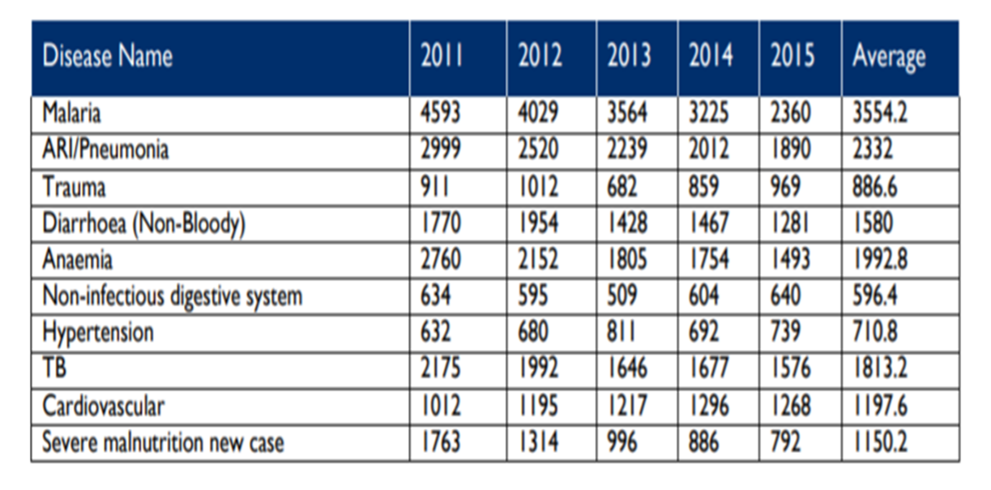
Source: HMIS-MoH
- Indicate why the problem cannot be solved by existing regulatory framework
- The existing legal framework is inadequate to regulate emerging and re-emerging food safety hazards which can adversely impact on human, animal and plant health. In addition, the current regulatory framework does not reflect the principles enshrined in the International agreements.
- Effective mechanism to promote food safety and enhance trade, requires interventions that compel all involved to adhere to the necessary provisions.

Step 2 – Setting Objectives
Main objective
To strengthen food safety management systems in the country in order to protect the public against health hazards and fraud in the sale and use of food.
Specific objectives
- To strengthen coordination of the food control system in order to eliminate duplication of effort by 2021.
- To regulate the sale and use of food additives in order to contribute 20% to the reduction of Non-communicable diseases by 2021.
- To regulate the production, processing and sale of food in order to decrease by 10% the risk of food borne illnesses by 2021.
- To provide for analytical services for food articles in order to facilitate trade by 2020
- To strengthen risk-based surveillance for integrated national system for food safety in order to enhance public health security by 2021

Step 3 – Options considered
- The ‘do nothing’ option
Maintaining the status core entails that the Ministry of Health does not put in place any new interventions. This means that the current challenges in the administration of the food law remains unresolved. The incidences of food borne illnesses and Non-communicable diseases will continue to rise and the health status of the population will negatively be impacted due to failure to assure the safety of food. Further, the ‘do nothing’ option will also mean that the country shall continue having challenges in food trade due to failure to adhere to international best practices.
In light of the foregoing, this option is NOT preferred.

- Legislation option
The Ministry of Health has the option of repealing and replacing the Food and Drugs Act Cap 303 of the Laws of Zambia with the Food Safety Act. This will enable the Ministry to regulate sale and use of food in order to protect the public from health hazards and facilitate trade. Additionally, the repeal and replace option will provide for analytical services for food articles that will also address emerging and re-emerging issues such as the drug residues, anti-microbial resistance, pesticide contaminations, genetically modified organisms, radiation, heavy metals, immune boosters, food supplements. The other reasons for repealing and replacing is to remove the drugs and cosmetics provision with its regulations from the Food and Drugs Act that were taken to the Medicines and Allied Substances Act No.3 of 2013; this will help streamline the powers of the Authorised Officers enshrined in the Act.
The Act shall also provide for the coordination mechanism in the food safety management systems.

- Information and education campaigns
The use of Information and education is one option that can be used as an indirect intervention. This method includes the use of both print and electronic media such as leaflets, brochures, posters and radio and TV programming.
In addition, the campaigns include community awareness programmes that are aimed at sensitizing the public on matters of food safety. These campaigns could also be extended to the food traders and raise awareness of issues of food safety.
However, this option, does not address most of the problems identified. It can only compliment other efforts towards the achievement of set objectives.

Step 4 – Comparisons of cost and benefits of options
Cost effectiveness analysis
The Cost effectiveness analysis which Involves comparisons of the cost of different regulatory options, where the benefits cannot be expressed in monetary terms was applied. This is mainly used in health, safety, education where impact maybe expressed as fewer deaths or better education system.
The burden of foodborne diseases to the public, welfare and to the economy of a country due to the difficulty in establishing the causal relationships between food contamination and resulting illness or death because of no scientific data. Additionally, foodborne diseases impede socioeconomic development by straining health care systems, and harming national economies, tourism and trade.
Globally, an estimated 600 million – almost 1 in 10 people in the world – fall ill after eating contaminated food and 420 000 die every year, resulting in the loss of 33 million healthy life years (DALYs). DALYs have a significant impact on the health on the population and economy of the country (WHO, 2018)
The increased cost of health care for food-borne illnesses and diseases in the population is preventable through the establishment of well-structured food safety systems. Added to this, WHO reports that consumption of unsafe food containing harmful bacteria, viruses, parasites or chemical substances, causes more than 200 diseases – ranging from diarrhea to cancers.
Advocating for food safety is an important component of health security and for integrating food safety into national policies and programmes in line with the International Health Regulations (IHR - 2005).
Furthermore, access to sufficient amounts of safe and nutritious food is key to sustaining life and promoting good health. This is achieved through the implementation of a well organised food safety system
In Zambia, hypertension is one of the leading causes for ill-health, premature mortality and disability. It is also a key risk factor for the development of cardiovascular disease (CVD). Hypertension is attributed to diet such as salt intake and fatty foods among all ages. In 2017, the incidence rate of hypertension in all ages was 10.4 per 1,000 population (HMIS, 2018). The burden of cardiovascular disease has a negative impact on economic development which includes the high cost of treatment, limited productivity and increase in inequalities (Siziya S et al. 2012)
Diarrhea also continues to be a major cause of childhood morbidity and mortality in Zambia. The cost per outpatient visit attributed to under-five diarrhea in Zambia was around US$26 (Chola and Robberstad, 2009). In 2017, the incidence rate of diarrhea in all ages was 106 per 1,000 population (MoH 2018).
The total health per capita expenditure for Zambia was estimated at US$ 69 in 2016 (MoH 2018). With a population estimated at around 16.4 million in 2017 (CSO 2018), cost of treating hypertension and diarrhea out stretches the total funds spent on health care. Interesting to note that the average cost of out-patient services for diarrhoea attributed to under-five diarrhea in Zambia is around at 38% of the per capita expenditure on health. This highlights the need for either increased expenditure to the health sector or, the need for preventive measures to free up the much-required resources.
The nutritional profile report of 2017 provides estimates for future losses and gains on life, economic productivity, permanent disabilities and human capital associated with various nutrition problems for the period 2017-2021.
There are no indicators currently in the HMIS that provides a direct correlation between food safety and ailments hence to address this problem, proxy data has been used for diseases were food safety is a contributing factor.
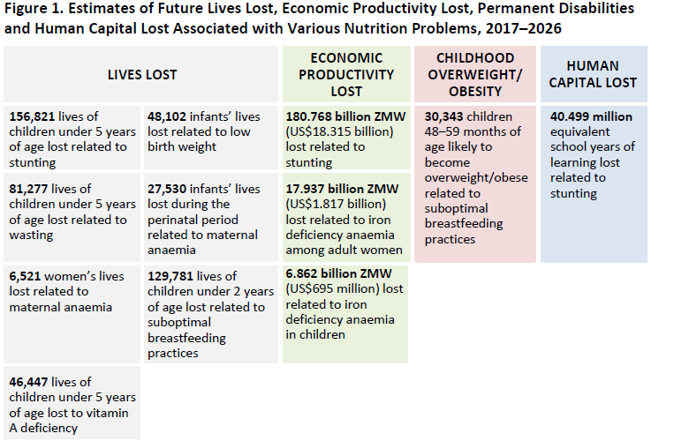
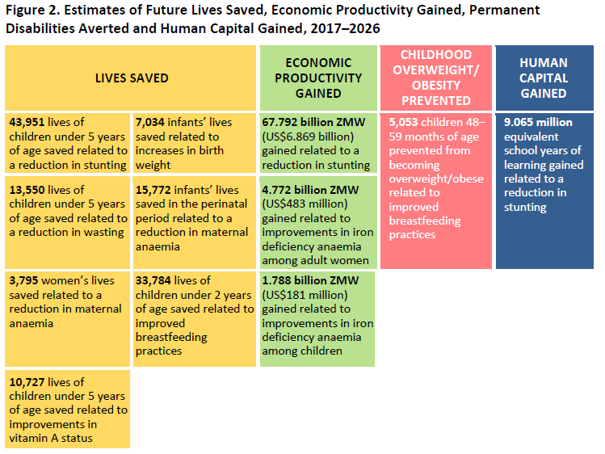
In the status quo scenario, the negative consequences are expressed, for example, in terms of lives lost, disabilities, human capital lost, and economic productivity losses as shown in figure 1 below. This relates to the HMIS data (2015) that shows the severe malnutrition among the top ten causes of morbidity at 792 per 1,000 population. When the results of the status quo and improved scenarios are contrasted, the differences reflect the benefits of improved nutrition, expressed as lives saved, disabilities averted, human capital gains, and economic productivity gains (MoH, 2017).
Figure 1: Status core scenario versus improved scenario
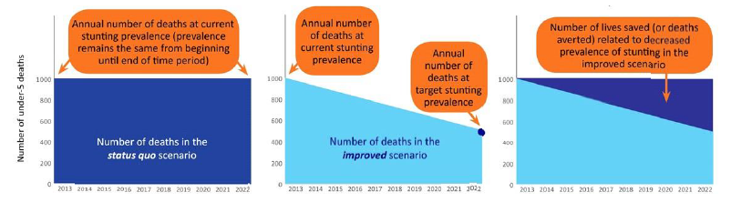
Step 5- Stakeholder consultations
The process of consultation to review the Food and Drugs Act Cap 303 commenced in 2012. A technical committee was constituted to spearhead the review. Consultations took the form of advisory groups, technical committee, stakeholder consultative meetings, informal consultation and circulation for comments.
A total of seven (7) consultative meetings have since been held with stakeholders from government institutions (regulatory agencies and Ministries), academia, research and business organizations. The list of institutions consulted is attached in the annexes.
The Bill has also been discussed in the National Codex Committee which is co-chaired by the Ministries of Agriculture and Livestock and Fisheries. Inputs from this committee which oversees issues of food safety in the country have since been considered for inclusion in the revision process.
Furthermore, the Bill circulated to Provincial Environmental Health Officers for dissemination and obtaining comments from the districts and lower levels. This was also done for the major local authorities.
In addition, a Cabinet memorandum was circulated to all Ministries for comments as per government procedure with all comments received and noted during subsequent follow-up meetings held.
The summary of the key issues discussed in the consultative meetings are provided in table 2 below:

Table 2: Issues raised from the meetings can be summarised in the following table:
S/N | MEETING | ISSUES RAISED | ACTION TAKEN
1. | Manchinchi Bay Meeting- 2012 | - Justifications for the amendment of the Food and Drugs Act Cap 303 | Consensus reached that the Food and Drugs Act Cap 303 be reviewed.  - Repealing the Act without replacing would create a vacuum while amending will create an opportunity to include new ideas in the Act such as the chemicals, poisons, pesticide and drug residues, contamination with heavy metals and provide an opportunity to review the regulations on salt and milk to include acceptable levels of melamine.  - Will strengthen the components of food safety laws that are currently not provided for and this will enhance trade locally and internationally,  - Repealing the Act will render the regulations obsolete as the F&DA is supported by subsidiary legislation (regulations) specific to each Food and Drug item,  - Issues of food safety and quality are not contained in other legislations as asserted and as such the amendment has been seen as opportunity to include detailed matters such as, emerging issues of contamination with radiation, heavy metals, drug residues, GMOs, immune boosters.  - To ensure all food meet consumer expectations in terms of nature, substance and quality and not misleadingly represented.  - To deal with labeling in a way that assures not only safety but dietary life styles e.g Organic declared.
2. | Kabwe Meeting - 2014 | - Provide analytical services to all law enforcement agencies and other stakeholders  - Rename the Act as Food and Drugs Act was reversed. The proposed name was Food Safety and Quality Act  - Name and functions of the Laboratory were defined  - Provide for the Application for a Health Clearance Permit under importation and exportation | The submissions made by other agencies were taken into consideration except for the analysis of narcotics and psychotropic and their precursors and essential chemicals which shall be analysed under ZAMRA. There will be need to appoint a Public Analyst under ZAMRA by the Minister:  - Drugs component has all been moved to the Medicines and Allied Substances Act  - The name of the Laboratory shall be changed to Food Safety Laboratory as there is an established National Drugs and Quality Laboratory
3. | Mika Meeting -2015 | - It was proposed to establish and maintain central data base of importers, exporters, manufacturers, distributors and retailers of food articles  - Addition of prohibition and emergency prohibition orders to ensure compliance so that there is no Health Risk condition in the population  - Provide for the establishment of the Food Safety Authority | The agreed actions were since effected except for the establishment of the Food Safety Authority which has since been changed to Coordinating Committee
4. | MoH-UCI-Technical Committee meeting | - Impact of bill on the treasury considering the establishment of the Authority  - Assess potential for duplication of functions and roles of the proposed Authority  - Consider strengthening the Zambia Bureau of Standards by charging it with additional functions | - Establish a lean structure composed of few personnel that specifically coordinate all the food safety implementing agencies  - Duplicated functions will be reviewed and correctly placed to line ministries. All functions that overlap with roles of other stakeholders will be streamlined and left to specific institutions  - Standards development function be left with MCTI (ZABS) under the Standards Act Cap 416. Standards can be used by issuance of an SI through referencing to the particular standard
5. | Anninas Meeting - 2017 | - Consensus was reached to exclude the wording “quality” from the title of the bill as it is the mandate of ZABS to formulate quality standards for promotion against technical barriers to trade (TBT) and the proposed title to read as “Food Safety Bill of 2017”.  - Consensus was reached that in order to have a sound food safety control management system, there is need to change from a multiple agency food safety control system to an integrated food safety control system.  - To consider recommendations from the various assessments undertaken on food safety control and management in Zambia  - the team resolved to have a food safety coordinating secretariat to be called a “Food Safety Coordinating Agency” with a lean structure of about four technical officers appointed from three key Ministries with a mandate in food, in order to be in line with the international best practices in food safety as per WHO/FAO structure such as the sanitary and phytosanitary (SPS) agreement, these are internationally referred to as the three sisters at international level | The agreed actions were since effected
6. | Nomads Meeting - 2018 | - Creation of the Authority to be removed and replaced by the Food safety coordinating Committee which will comprise a lean structure (Human, plant and animal health)  - To be housed at MoH under the department responsible for food safety  - functions of the authority aligned to the food safety coordinating committee  - Agreed to remove the Board from the Bill  - To introduce the concept of HACCP in the bill to protect the citizens  - Administrative fees | Changes have been effected
7. | National Codex Committee | - The membership of the coordination committee to be representative of the codex committee  - A concern was raised as to where the Food Safety Authority would be housed?  - Those present during the meeting were informed that the Food Safety Authority would operate like any other similar established authorities such as the Zambia Medicines Regulatory Authority, Zambia Radiological Control Board etc. | Changes have been effected

Step 6 – Selecting the preferred options and making recommendations
The Ministry of Health has recommended a legislative option (option number two), which is to repeal and replace the Food and Drugs Act Cap 303 with the proposed Bill ‘the Food Safety Bill’.
This will enable the Ministry to regulate sale and use of food in order to protect the public from health hazards and facilitate trade. Additionally, the repeal and replace option will provide for analytical services for food articles and address emerging and re-emerging issues that are not covered in the current Act. In addition, enactment of the Bill will ensure an efficient and effective food control system. This option was supported by stakeholders during consultative meetings held.
In comparison with the other options identified in the RIA, the legislative option is the only option that will address the problem.
The other two options are not recommended as they either perpetuate the current challenges in food safety or do not address the problem in its totality.

Step 7 - Implementation, Monitoring and Evaluation
Food Safety Implementation Plan

 | Objective | Activities | Inputs | Output | Budget | Timeframe | Responsible/Department
 | To strengthen food safety management systems in the country in order to protect the public against health hazards and fraud in the sale and use of food.
1. | To strengthen coordination of the food control system in order to eliminate duplication of effort by 2021. | Establishment of the Food Safety coordinating committee | - Appointment of Food Safety Committee members  - Office accommodation and furniture  - Appointment of Authorized Officers | Food safety coordinating committee operationalized | Nil | QTR 2 2019 | Public Service Commission  DHPESD  Minister
 |  | Streamline areas of duplication/overlap | - Desk Review of institutional mandates | Guiding documents developed | 5,000 | QTR 3 2019 | DHPESD
 |  | Quarterly Food Safety review meetings with stakeholders | - Organizing of the venue/conferencing  - Preparation of relevant documents for the meeting | Strong linkages established | 40,000 | Quarterly | DHPESD
2. | To regulate the sale and use of food additives in order to contribute 20% to the reduction of Non-communicable diseases by 2021. | Development of Technical regulations and Standards for food | - Organizing of the venue/conferencing  - Preparation of relevant documents for the meeting | Technical regulations developed | 1,000,000 | QTR 1 2019 | MoH  ZABS  DTR
 |  | Review of inspection protocols to harmonize Inspections food | - Draft Inspection protocols  - Organizing of the venue/conferencing  - Preparation of relevant documents | Compliance with the enacted law on food safety and regulations | 500,000 | QTR 1 2020 | MoH
 |  | Issuance of appropriate authorization documents | - Review of health permit, applications for import and export of food, application forms | Enhanced compliance and trade facilitation | 200,000 | Ongoing | MoH
 |  | Monitoring of foods and the impact on NCDs | - Review HMIS data on NCDs | Monitoring mechanisms developed | 10,000 | QTR 1 2020 | HPESD-(MoH)
 |  | Review of HMIS data to incorporate foodborne diseases | - Organizing of the venue/conferencing  - Preparation of relevant documents | Food borne diseases indicators incorporated in the HMIS | 300,000 | QTR1 2020
 |  | Risk assessment | - Data analysis  - Risk profiling | Reduced foodborne events | 200,000 | QTR 2 2020 | MoH
 |  | Health promotion campaigns | - IEC materials  - Print media  - Radio and TV  - Community engagement | Food safety awareness created | 1,000,000 | Quarterly | MoH
3. | To regulate the production, processing and sale of food in order to decrease by 10% the risk of food borne illnesses by 2021. | Conduct inspections of food at all levels in the food continuum | - Inspection protocols  - PPE  - Sampling equipment  - Sample collection | Food articles inspected | 800,000 | Ongoing | HPESD-(MoH)
 |  | Stakeholder Review Meetings | - Identification of relevant food businesses organizations (FBOs)  - Organizing of the venue/conferencing  - Preparation of relevant documents for the meeting | Review meetings held | 40,000 | Quarterly | HPESD-(MoH)
 |  | Analysis of food articles for comparison with regulations/standards | - SOPs  - Reagents (chemicals and media)  - Equipment  - PPE | Standards/regulations provided for all food articles | 1000,000 | Ongoing | HPESD-(MoH)/ ZABS/FDCL
 |  | Implementation of HACCP/GMP | - Conduct audit  - Trainings on HACCP/GMP  - Identification of CCPs  - Review of performance and provide feedback | HACCP/GMP implemented | 500,000 | Ongoing | HPESD-(MoH)
4. | To provide for analytical services for food articles in order to facilitate trade by 2020 | Accreditation of the food and Drugs Control laboratory | - Equipping the laboratory with newer technology  - Procurement of ISO standards  - Rehabilitation of laboratory infrastructure to increase space | Food and rugs Control Laboratory Accredited | 50,000,000 | QTR 3 2020 | Food and Drugs Control Laboratory
5. | To strengthen risk-based surveillance for integrated national system for food safety in order to enhance public health security by 2021 | Desk review of the risk-based surveillance tools | - Internet connectivity  - Stationery | Tools for conducting risk-based surveillance are developed | 1,000 | QTR 3 2019 | ZNPHI/ HPESD
 |  | Conduct meeting to develop uniform risk surveillance tool for all regulators | - Organizing of the venue/conferencing  - Preparation of relevant documents for the meeting |  | 400,000 | QTR 3 2020
 |  | Conduct risk-based surveillance for food safety | - Fuel  - Per diem  - Personnel  - Tools  - Sampling and lab analysis | Risk based surveillance is conducted | 1000,000 | Ongoing | ZNPHI/ HPESD

ANNEXES
Annex 1: List of Institution consulted
- Ministry of Health
- Ministry of Agriculture
- Ministry of Livestock and Fisheries
- Ministry of Commerce and Industry
- Ministry of Local Government
- Ministry of Justice
- Veterinary Association of Zambia
- University of Zambia (School of Vet)
- University of Zambia (School of Public Health)
- Department of Veterinary Services
- Food and Drugs Control Laboratory
- Zambia Bureau of standards
- Zambia Institute of Environmental Health
- National Biosafety Authority
- National Institute for Scientific and Industrial Research
- Lusaka City Council
- Zambia Compulsory Standards Agency
- Zambia Environmental Management Agency
- Business Regulatory Review agency
- Ministry of Home affairs (DEC)

REGULATORY IMPACT ASSESSMENT REPORT FOR THE FOOD SAFETY BILL

